CIS 554 Homework 5

Homework Objective: Provide students with an opportunity to work with multi-dimensional vectors and functions.

Due Date: Refer to CIS554 Blackboard

Description: Character Fonts

- Write a C++ class, WordFont, that will read a word that you input, and draw it on the screen with a character height and width that you specify.
- You will use a 2-dimensional vector data structure to draw your word. The 2-dimensional vector will be used to maintain the location of each “pixel” of the input word characters
- Once the vector has been populated with all the letters of the word, using the drawing character specified by the user, with the proper font, you will print out the contents of the vector to the screen to print the entire word.
- You may choose to implement a subset of the English alphabet, but you must tell the user what the valid letters are when you prompt for the word. You MUST implement at least 15 letters, including the vowels a, e, i, o and u.
- Each letter must be implemented in the WordFont class as a separate method.
- Each letter method must have the proper parameters to allow it to 1) be placed anywhere in the word, 2) use the correct pixel (i.e. drawing character), and 3) adjust to the font size.
- You may limit the word to a certain number of characters, but you must inform the user of any limitations (e.g. limit the word size to 8 letters or less).
- You must have a separate method in your class that prints out the word that is represented by the pixels in the 2-dimensional vector.
- The output of the program might look something like that shown below.

Bold Word Example
Enter a word (8 letters or less), using a, e, i, o, u, c, b, d, f, g, h, j, k, l, m, n, r, s, t: cat
Enter the pixel character you want to use to draw: *
Enter the Font Size (8-12): 8
Bold? (0=No, 1=Yes) 1

******** ******** ********
******** ** ** ********
** ** ** **
** ******** **
** ******** **
** * ** **
******** ** ** **
******** ** ** **

Press any key to continue

Non-Bold Word Example
Enter a word (8 letters or less), using a, e, i, o, u, c, b, d, f, g, h, j, k, l, m, n, r, s, t: cat
Enter the pixel character you want to use to draw: *
Enter the Font Size (8-12): 8
Bold? (0=No, 1=Yes) 0

******** ******** ********
* * * *
* * * *
* ******** *
* * * *
* * * *
* * * *
******** * * *

Press any key to continue

Submission: Provide the information as follows:

- Submit zipped source files to the Blackboard.

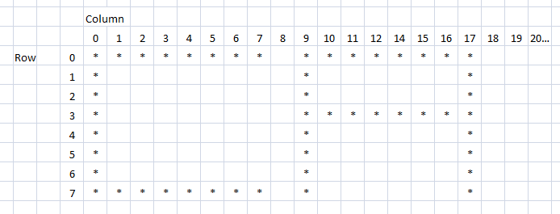
Hint: The 2-dimensional vector is used as follows. Note that for the given word CAT, the pixels of the C and A letters are represented in the 2-dimensional vector as the “*” character, selected by the user. Because the font size of 8 was input by the user, each character is 8x8 pixels.

Hint: The following code snippet demonstrates how to declare and initialize a MxN multidimensional vector. Note that in the constructor we use the class initialization list (starts with a :). I suggest copying and pasting this code into a Visual Studio project so you can run it, view the output, and see how it works.

#include <vector>
using std::vector;

#include <iostream>
using std::cout;
using std::endl;

#include <iomanip>
using std::setw;
using std::right;

class MultiDem
{
public:
MultiDem();
void PrintMultiDem();

private:
// vector declaration
vector<vector<int>> myMultiVector;
};

MultiDem::MultiDem()
// using the class initialization list to
// construct vector as a [10][5] mulitdemensional vector, initialized to all 0
: myMultiVector(10,vector<int>(5,0))
{

// iterate through the vector and put some data in it
for (int rows=0; rows<myMultiVector.size(); rows++)
{
for (int cols=0; cols<myMultiVector.at(0).size(); cols++)
{
// put some data in each row and column using the vector.at() method
myMultiVector.at(rows).at(cols) = rows + cols;

// alternatively, this would work as well, and be acceptable
// myMultiVector[rows][cols] = rows + cols;
}
}
}

void MultiDem::PrintMultiDem()
{
for (int rows=0; rows<myMultiVector.size(); rows++)
{
for (int cols=0; cols<myMultiVector.at(0).size(); cols++)
{
// put some data in each row and column, using subscript notation
cout << setw(4) << right << myMultiVector[rows][cols];

// alternatively, this would work as well, and be acceptable
// cout << myMultiVector.at(rows).at(cols);
}

// put a new line before printing the next row of data
cout << endl;
}
}

int main()
{
MultiDem md;
md.PrintMultiDem();
}

